An-Najah National University College of Information Technology & AI

Department of Computer Science Design and Analysis of Algorithms Homework #3

In this homework, you are required to implement Kruskal’s algorithm using the Disjoint Sets (Union-Find) data structure, along with additional graph functionalities.
The input: Undirected connected weighted graph.
The output:
- Is the graph connected? If the graph is not connected, display the message: “The graph does not have a spanning tree because it is not connected” and display the number of connected components of the graph.
Hint: Use Union and Find data structure to perform this task. Another way to solve it is
using Kruskal’s algorithm.

- The MST (Minimum spanning tree) created by Kruskal’s algorithm.
- The sets that are created in each step of executing the algorithm until they become one single set.
- The parent array created during the process of finding the MST.
- The weight of the MST.
- Does the graph have any cycles? Or is it acyclic (has no cycles)?
- Display a path between 2 nodes entered by the user (any path if it exists). Notes:
  - Use Union and Find (version 3): Union by rank and FindSet with path compression.
  - The following graphs are just examples, your code must be able to work on any graph with any number of nodes.

Example1:
Input: The graph (entered as an array of objects)

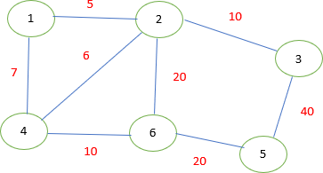

The Output:
The graph is connected, it has one connected component. The sets:
Step1: {1} {2} {3} {4} {5} {6}
Step2: {1, 2} {3} {4} {5} {6}
Note: the order of the elements in the sets is NOT important.
Step3: {1, 2, 4} {3} {5} {6}
Step4: {1, 2, 4, 3} {5} {6}
Step5: {1, 2, 4, 3, 6} {5}
Step6: {1, 2, 4, 3, 6, 5}
The final parent array: -6, 1, 1, 1, 1, 1
The MST edges: (1,2), (2,4), (2,3), (4,6), (5, 6)
The weight of the MST is: 51 The graph has cycles.

Output: Enter two nodes to find a path between them or enter -1 to exit.

Input: 1, 5
Output: 1, 2, 6, 5
Enter two nodes to find a path between them or enter -1 to exit.
Input: 1, 2
Output: 1, 4, 2
Enter two nodes to find a path between them or enter -1 to exit. Input: -1
Output: Goodbye!

Example2:
Input: The graph (entered as an array of objects)
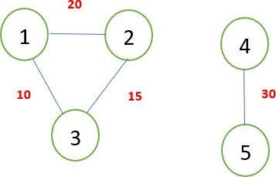
The Output:
The graph is not connected, it has 2 connected components.
The graph does not have a spanning tree because it is not connected. The graph has cycles.
Output: Enter two nodes to find a path between them or enter -1 to exit. Input: 1, 3
Output: 1, 3
Enter two nodes to find a path between them or enter -1 to exit.
Input: -1
Output: Goodbye!

